MAYOR
Doug Haynie

COUNCIL MEMBERS
Cindy Bone
Jenny Buley
Denise Black
Tom Hays
Ron Smith
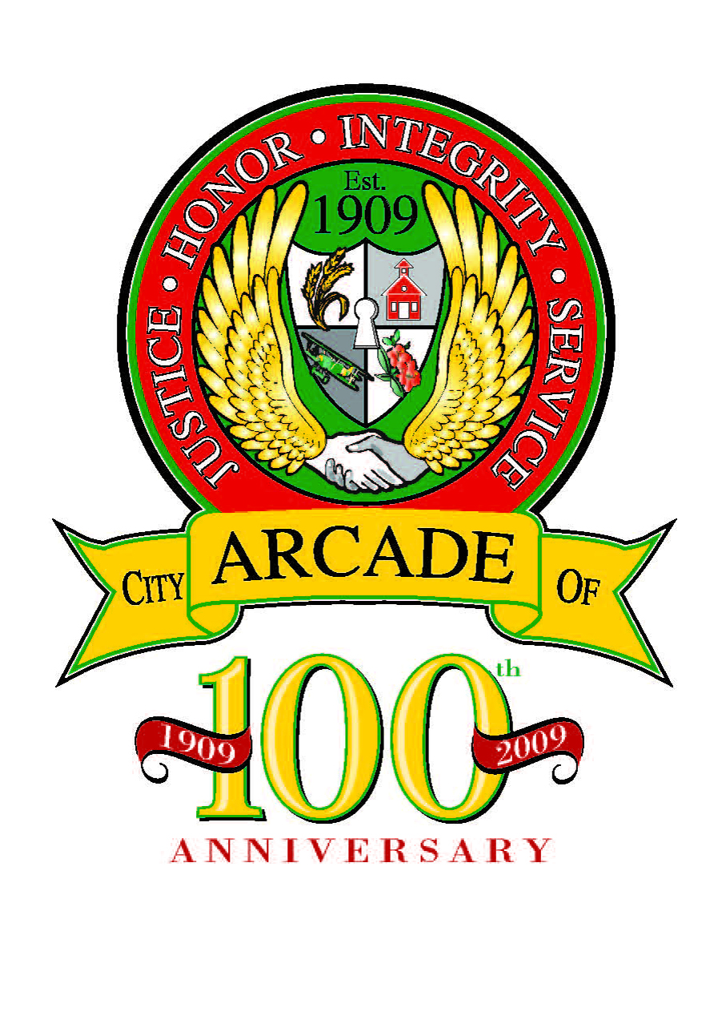

ARCADE CITY COUNCIL MEETING
April 10, 2023
7:00 P.M., CITY HALL

AGENDA
ORDER OF BUSINESS:

- CALL TO ORDER:

- ROLL CALL:

- PLEDGE OF ALLEGIANCE:

- REVIEW AND APPROVAL OF MINUTES FROM PREVIOUS MEETINGS:
- March 13, 2023 - City Council Meeting

5. REPORTS FROM STANDING COMMITTEES:
- Audit/Finance……………………………………………… Council Member C. Bone
- Legal……………………………………………………………. Council Member R. Smith
- Parks/Roads/Grounds…………………………………… Council Member T. Hays
- Social Media.…………………………………………………. Council Member J.Buley
- Special Events…………………………………………………. Council Member
- Police Department…………………………………............Chief Mike Adams

- UNFINISHED BUSINESS: Tabled on February 13, 2023
a. Jared Lill Requesting a Business License to operate Rhino Mini Storage at the Corner
of 82 South and Hwy. 129, Jefferson, GA 30549.

- NEW BUSINESS:
- Teara Damons Requesting a Business License to change the name of Bulldog Mobile Home
Park and to operate under the new name of Harry’s Mobile Estate located at 2570
Athens Hwy., Jefferson, GA 30549

- Request for Approval of Painting Contract-CertaPro Painters-Interior of City Hall and Police Department.

- CITIZENS REQUESTING TO SPEAK:

- OTHER BUSINESS:

- ADJOURNMENT:


3325 Athens Highway ▪ P. O. Box 417 ▪ Jefferson, Georgia 30549 ▪ Phone: 706-367-5500 ▪ Fax 706-367-1914 www.cityofarcade.org

